**REES Projektni zadatak – Dijagrami   
Tema: DataCache ( gr. 4. )**

**Student:  
Todorović Uglješa**

**Asistent:  
Asistent-Master   
Janković Zoran**

**Novi Sad, juni 2021.**

**SADRŽAJ**

1.Component Diagram 3

2. Class Diagram Client 4

2.1.1. Pomoćne klase 4

2.2 UI klasa 4

3. Class Diagram Distributed Database 5

4. Struktura baze podataka 6

5. Sequence Diagrams 7

# **1.Component Diagram**

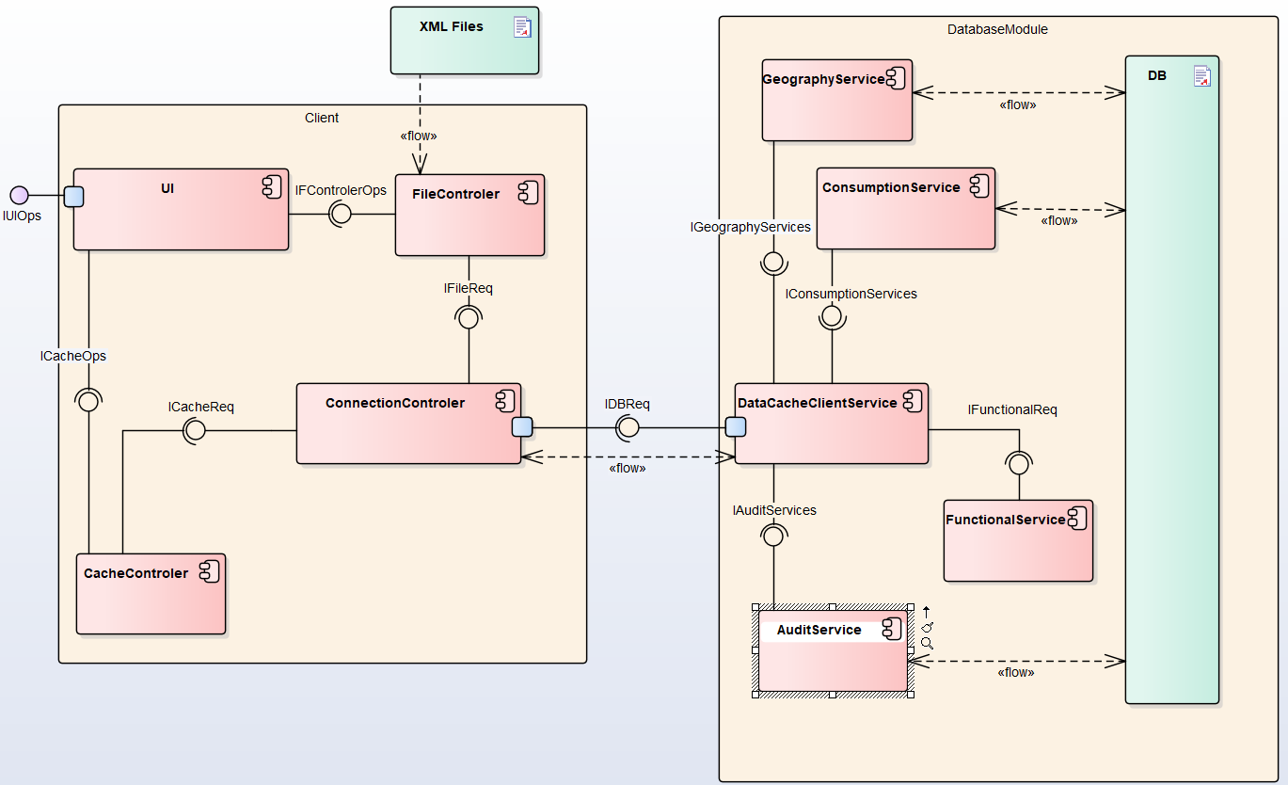

# 2. Class Diagram Client

## 2.1.1. Pomoćne klase

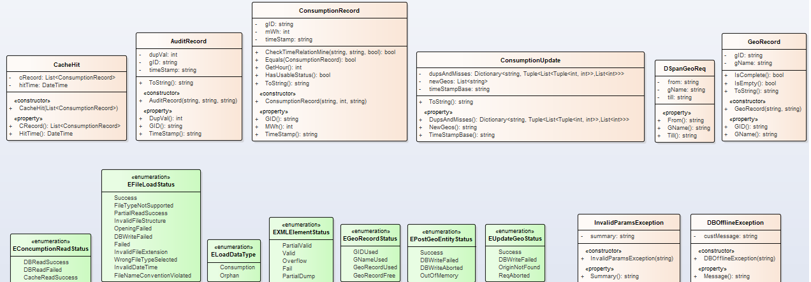Sl. 2.1.1.1. Pomoćne klase, enumeracije i izuzeci

## 2.2 Client

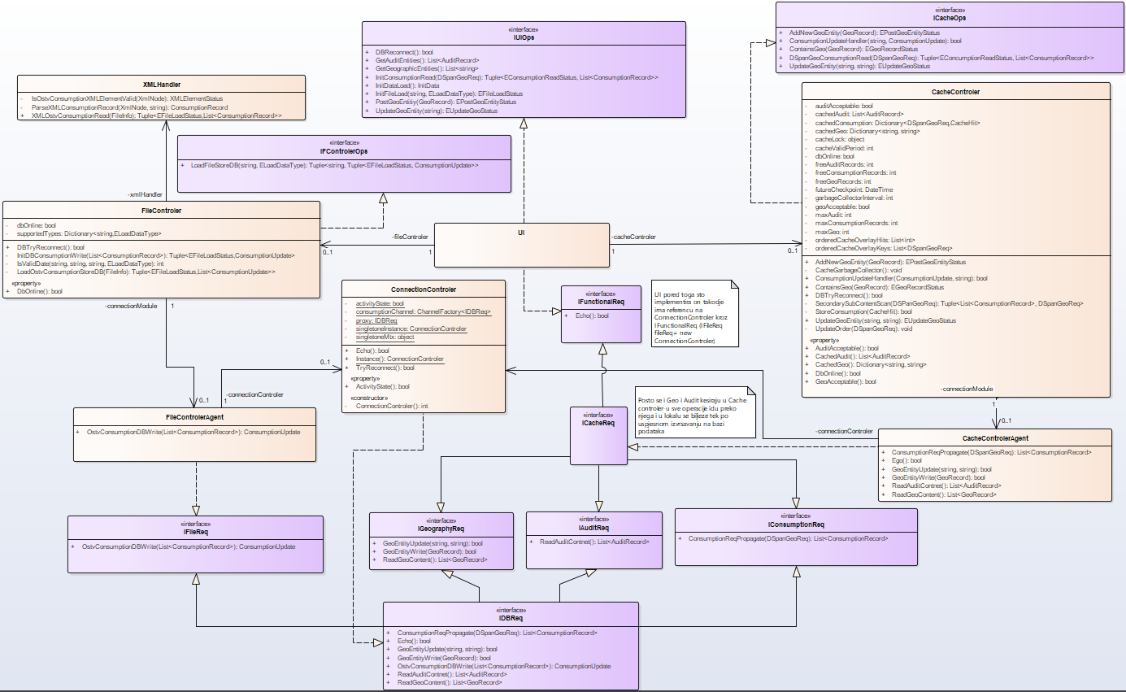Sl. 2.2.1. Klasni dijagram klijentskog dijela aplikacije

# 3. Class Diagram Distributed Database

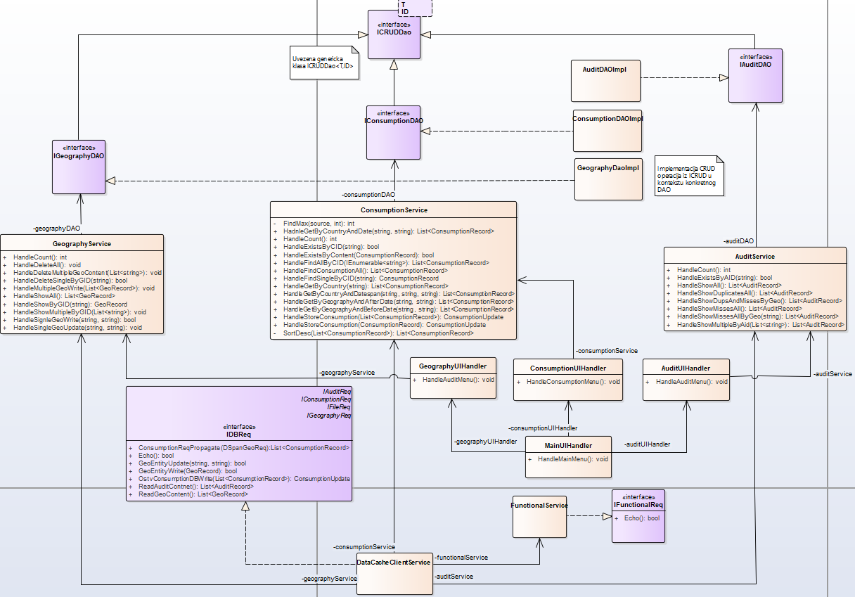Sl. 3.1. Klasni dijagram distribuirane baze podataka

# 4. Struktura baze podataka

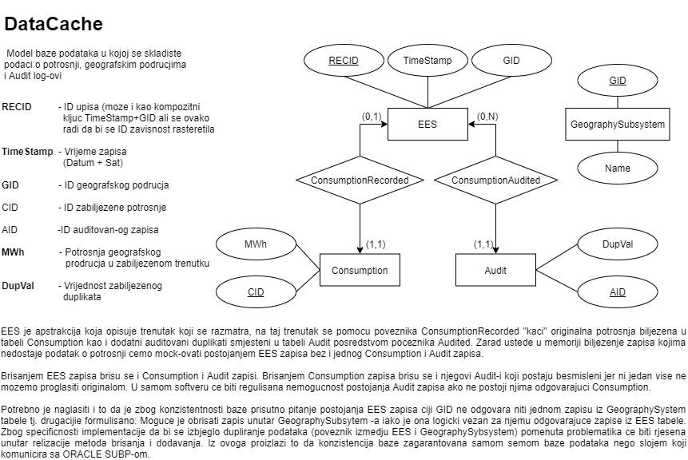

# 5. Sequence Diagrams

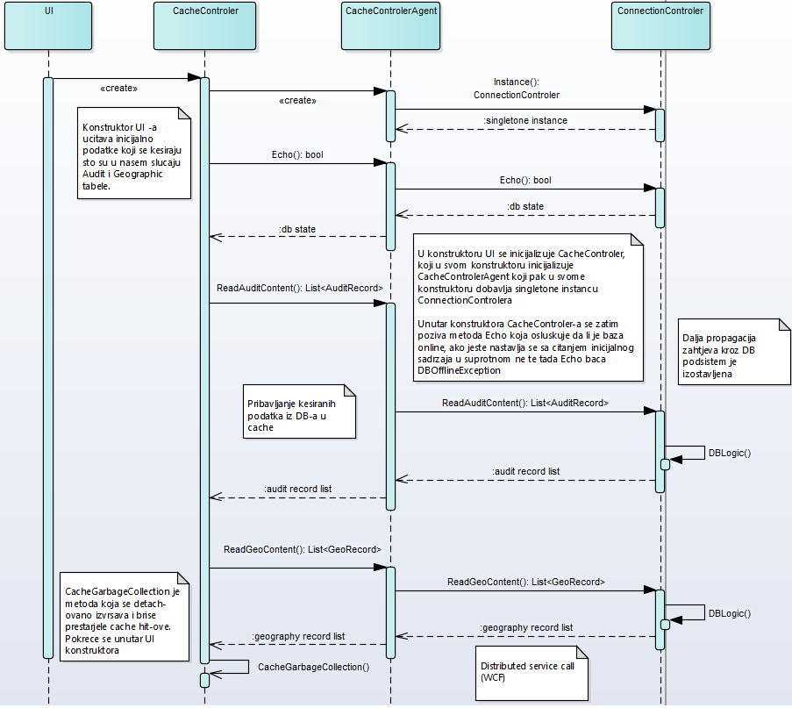Sl. 5.1. Caching Initial Data

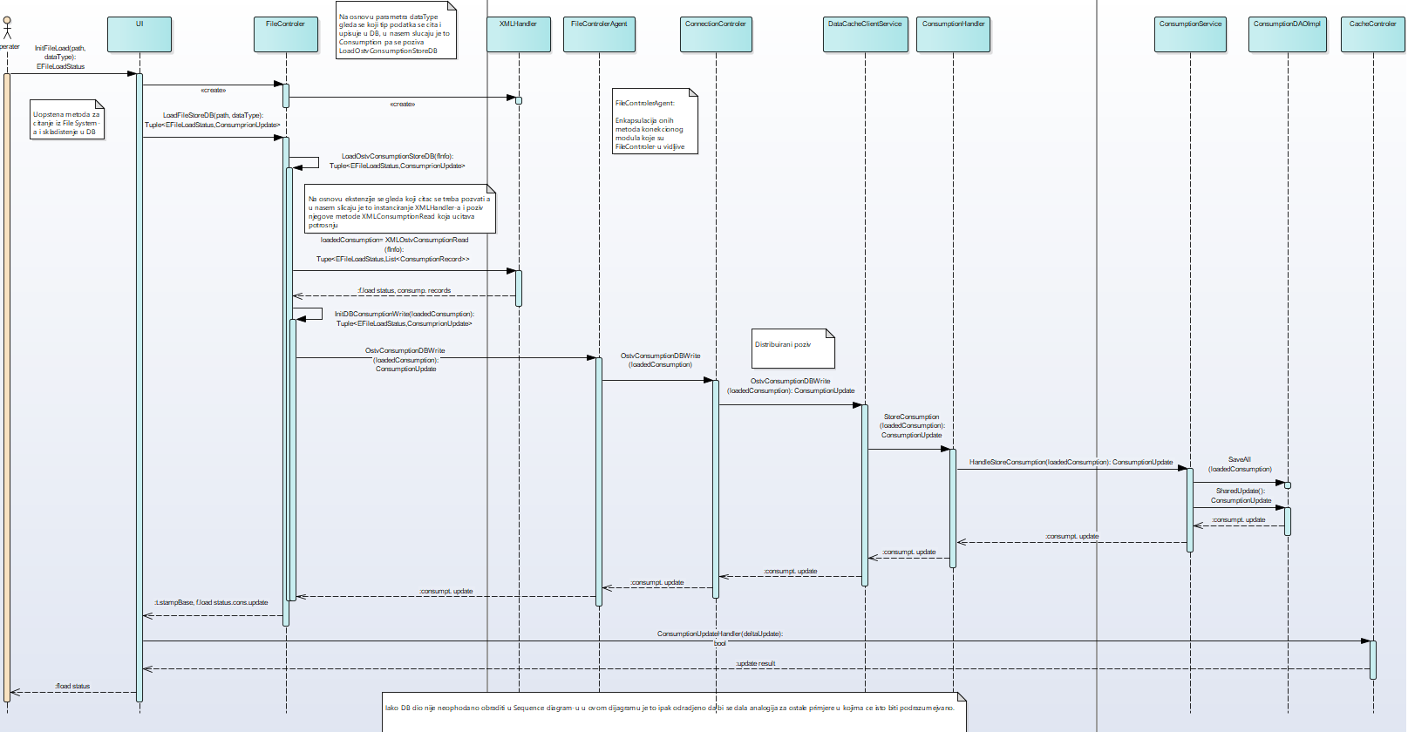 Sl. 5.2. Importing Data From XML File

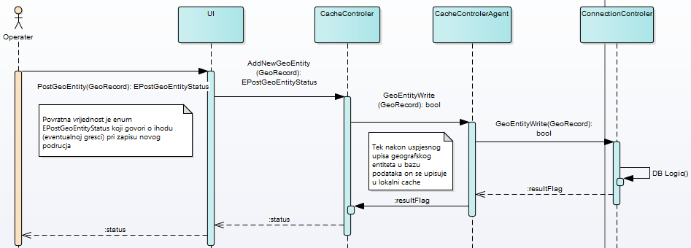Sl. 5.3. Posting Geographic Entity

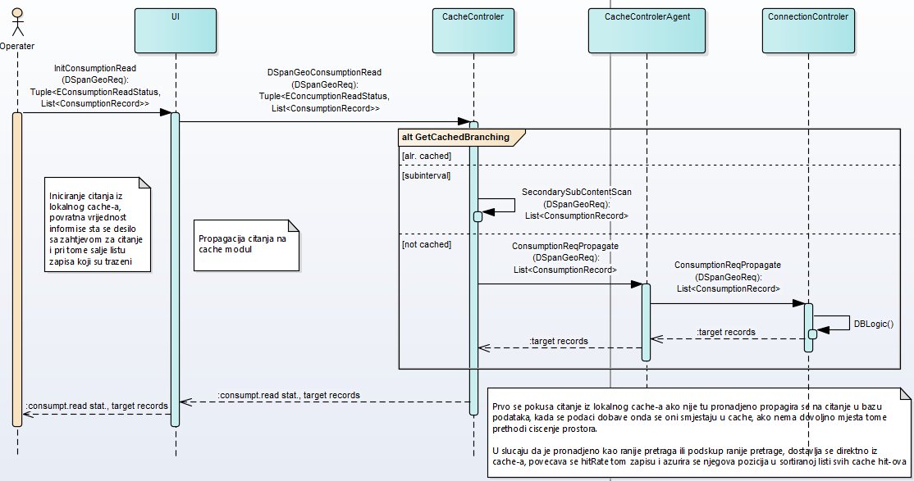 Sl. 5.4. Reading Consumption

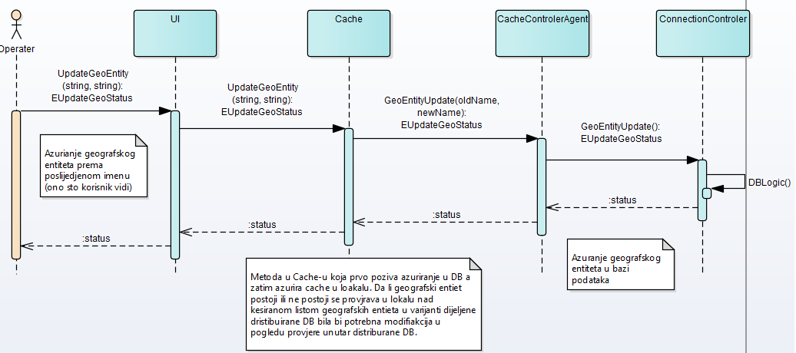Sl. 5.5. Updating Geographic Entity